ADVANCED SOFTWARE ENGINEERING
MID TERM(HACKATHON) REPORT

Architecture diagram:

Explanation:
User will create event, invite invitees and scans gifts by using barcode scanner and add them into users wish list, then only invitees are able to see the users wish list and they can order the gifts accordingly to the user’s interest.
Invitees can know who are buying the which gifts on users wish list.

Class diagram:

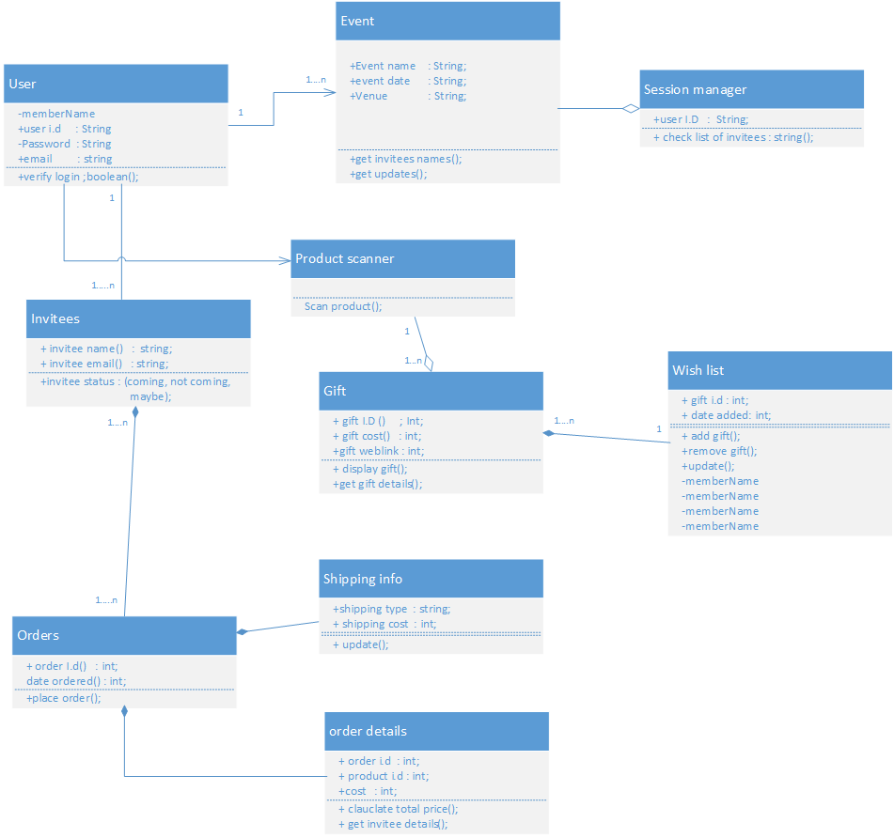

Features implemented:
I created the login page for the user to sign in and members to register and members page to view the members.
I followed the link http://msdn.microsoft.com/en-us/library/879kf95c(v=vs.100).aspx and I did the things in it like drag and drop for creating all the pages which I done up to now.
It will just create the drag and drop from tool bar for login page and all it will set an one reference file for web application and it sets one hyper link to reference page by creating individual pages and defines one name for each page.
After that it goes to security page for creating of database and some security questions for the user to create an account to maintain database on server.
And then we can run as “application(reference file)” in browser, form there we can add new members and view members page.

Screen shot for login page:

Screenshot for register page:

Screenshot for web application page:

Screen shot of logged in user:

Screenshot of members page:

Screenshot showing successful registration of user:

Screenshot showing the logged in of another user:

Data base:
According to the reference site I mentioned above it will create the database automatically in the SQL server without filling the tables in the visual studio. It will creates the database while authorizing the forms of the security and it also denys the unknown user who wants to see into the page.
Limitations:
- I tried to create the event manually, but it got failed because it needs manual entry of database by creating tables.
- I also tried to implement the barcode scanner using the scandit website, but it will allow just an access to one website with the product i.d.
- I tried to deploy into cloud, but my cloud wants to create a new password, when I enter new password, it was collapsed.
References:
www.stackoverflow.com
www.codeacademy.com
www.scandit.com

